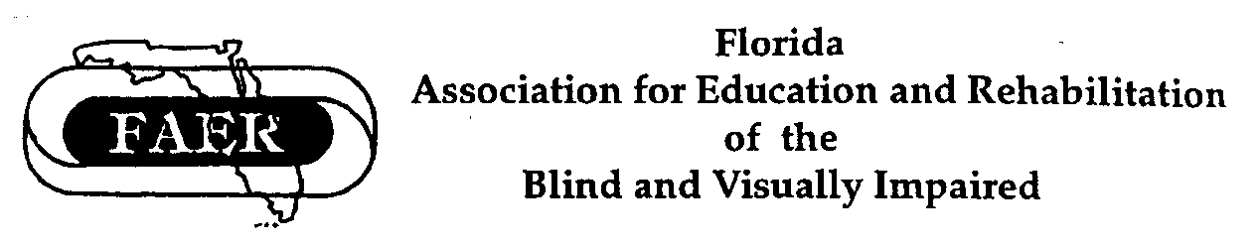

FAER

Application for Purvis Ponder

Orientation & Mobility Memorial Honorarium (2020-2021)
(Application Deadline: November 1, 2020 | Transcripts and letters of recommendation due: November 1, 2020)

This award is in memory of Purvis Ponder as a tribute to his years of dedication, commitment, and leadership within the field of orientation and mobility for persons with disabilities. The intent of this award it to keep the spirit of Purvis’ life work alive by assisting others to also follow in the course of study of orientation and mobility.

The Purvis Ponder Memorial Honorarium is limited to graduate students who have been admitted as degree seeking students enrolled for at least 3 hours in a qualifying program at an institution of higher education that prepares professionals to provide orientation and mobility services to individuals with visual impairments. The scholarship(s) may be granted prior to enrollment, but payment will require verification of enrollment each semester of its duration.

By accepting the Purvis Ponder Memorial Honorarium, a recipient pledges to be employed, following graduation, in a program or agency serving individuals with visual impairments in the State of Florida. This employment will be required for the duration of the funding that was received. For example, a student who has received funding for two semesters (nine months) will provide service in an education, rehabilitation, or related Florida position for at least nine months, or the funding will be returned to FAER. Should repayment not be made, collection agency intervention will be applied, and potential employers notified.

Promissory Statement:

By completing this application, I promise to abide by the above-stated policy, and will
- begin work in an agency/program providing services in the state of Florida within 6 months of graduation and
- provide professional services in a qualifying agency/program in Florida for a period of time not less than the period for which funding was received.

If neither of the conditions described in a nor b, above, are not met, I promise to contact the Scholarship Committee Chair at FloridaAER@gmail.com to discuss a repayment plan to return the full amount of the scholarship to FAER within 6 months.

Signature Date

Formal Application

- Personal Information:

Name of Applicant:

Current Mailing Address (Including City, State, and Zip code):
Telephone:

Email:

Permanent Address (of Name and Address of someone who will always know where/how to reach you after graduation):

Relationship to You:

Telephone:

Email:

- Academic Program:

What college or university do you attend?
Who is the person in charge of your program in orientation & mobility?

What is the title of that person?

What is the address of that person?

Telephone:

Email:

Please have that person, or another faculty member who knows your work, send a letter of verification to the Chairperson of the Scholarship Committee at FloridaAER@gmail.com.

- Progress:

When do you plan to graduate?

What are your current credit hours, related to O&M?

What is your current major?

What is your grade point average to date?

Who is your advisor?
Advisor's Telephone:
Advisor’s Email:
Current economic support for your education (self, family funds, loans, other scholarships, etc.) Priority consideration may be given to those demonstrating financial need.

- Please arrange for the following information to be sent directly to the Scholarship Committee at the address at the end of this application

  - Two letters from professional references (one must be from a faculty member in your current program).

  - Transcripts (official or unofficial) should be sent directly to the Scholarship Committee at the address at the end of this application, to arrive by November 1.

- Written Statement:

Please provide a written statement that describes your career goals, your experience in the field of visual impairment, and your hopes for the coming years. Let the committee know of any special experiences or interests that pertain to the goals of FAER.

Please send the complete application (signed on the first and last pages), including the written statement, and have the transcript and two letters of recommendation either sent via email to FloridaAER@gmail.com or mailed to:

Ms. Christine Telford, Chairperson
FAER Scholarships Committee
206 Ave D NW
Winter Haven, FL 33881

I hereby attest to the fact that the above statements and responses are factual and true. (Please sign and date)

Signature Date

Checklist for Purvis Ponder Memorial Honorarium Application:

- Complete and sign the promissory statement on page 1.

- Complete application starting on page 2.

- Ask your university program coordinator to send an e-mail to the Scholarship Chair confirming current enrollment in your program.

- Request that a copy of your unofficial transcript be sent to the Scholarship Chair.

- Request that two letters of recommendation be sent to the Scholarship Chair.

- Complete the written statement.

- Sign the application.

- Send the application and statement to the Scholarship Chair.

Email: FloridaAER@gmail.com

Or Mailed:
Ms. Christine Telford, Chairperson
FAER Scholarships Committee
206 Ave D NW
Winter Haven, FL 33881

